Blinkit Sales Querys

- See all the data imported:
SELECT *
FROM blinkit_sales;
DATA CLEANING:
In this dataset, we have some incorrectly labeled data. For example, in "Item_Fat_Content", we have inconsistent data names such as 'LF', 'low fat', and 'reg', so we want to standardize the data to 'Low Fat' and 'Regular'.
UPDATE blinkit_sales
SET Item_Fat_Content =
CASE
WHEN Item_Fat_Content IN ('LF', 'low fat') THEN 'Low Fat'
WHEN Item_Fat_Content = 'reg' THEN 'Regular'
ELSE Item_Fat_Content
END;

After Cleaning:
SELECT DISTINCT Item_Fat_Content
FROM blinkit_sales

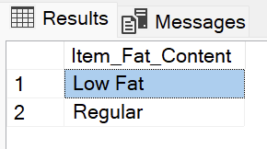

- KPI’s

- TOTAL SALES:
SELECT CAST(SUM(Total_Sales) / 1000000.0 AS DECIMAL(10,2)) AS Total_Sales_Million
FROM blinkit_sales
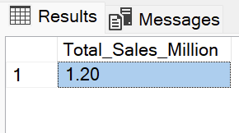

- AVERAGE SALES:
SELECT ROUND(AVG(Total_Sales), 2) AS Avg_Sales
FROM blinkit_sales
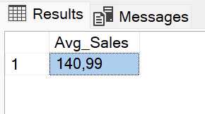

- NO OF ITEMS:
SELECT COUNT(*) AS No_of_Orders
FROM blinkit_sales

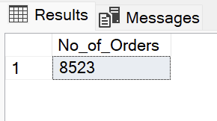

- AVERAGE RATING:
SELECT CAST(AVG(Rating) AS DECIMAL(10,1)) AS Avg_Rating
FROM blinkit_sales
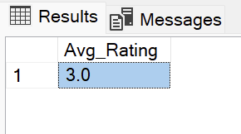

- Chart

- TOTAL SALES BY FAT CONTENT:
SELECT Item_Fat_Content,
CAST(SUM(Total_Sales) AS DECIMAL(10,2)) AS Total_Sales
FROM blinkit_sales
GROUP BY Item_Fat_Content
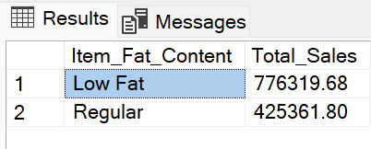

- TOTAL SALES BY ITEM TYPE:
SELECT Item_Type,
CAST(SUM(Total_Sales) AS DECIMAL(10,2)) AS Total_Sales
FROM blinkit_sales
GROUP BY Item_Type
ORDER BY Total_Sales DESC
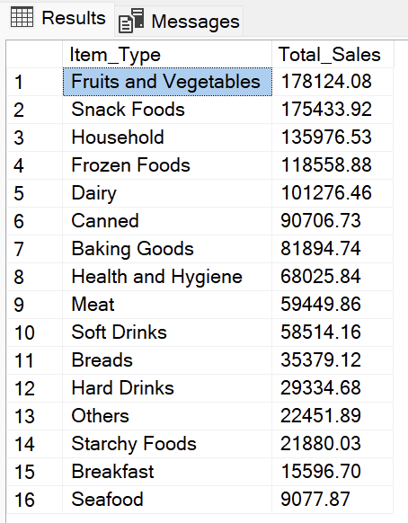

- FAT CONTENT BY OUTLET FOR TOTAL SALES:
SELECT Outlet_Location_Type,
ISNULL([Low Fat], 0) AS Low_Fat,
ISNULL([Regular], 0) AS Regular
FROM
(
SELECT Outlet_Location_Type,
Item_Fat_Content,
CAST(SUM(Total_Sales) AS DECIMAL(10,2)) AS Total_Sales
FROM blinkit_sales
GROUP BY Outlet_Location_Type, Item_Fat_Content
) AS SourceTable
PIVOT
(
SUM(Total_Sales)
FOR Item_Fat_Content IN ([Low Fat], [Regular])
) AS PivotTable
ORDER BY Outlet_Location_Type
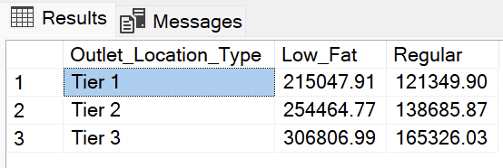

- TOTAL SALES BY OUTLET ESTABLISHMENT:
SELECT Outlet_Establishment_Year,
CAST(SUM(Total_Sales) AS DECIMAL(10,2)) AS Total_Sales
FROM blinkit_sales
GROUP BY Outlet_Establishment_Year
ORDER BY Outlet_Establishment_Year
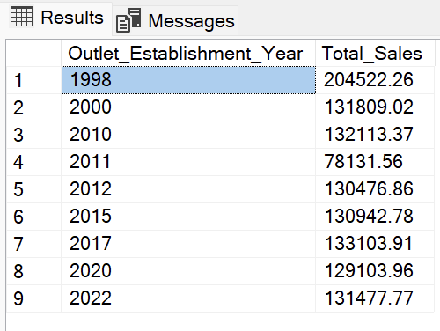

- PERCENTAGE OF SALES BY OUTLET SIZE:
SELECT Outlet_Size,
CAST(SUM(Total_Sales) AS DECIMAL(10,2)) AS Total_Sales,
CAST((SUM(Total_Sales) * 100.0 / SUM(SUM(Total_Sales)) OVER()) AS DECIMAL(10,2)) AS Sales_Percentage
FROM blinkit_sales
GROUP BY Outlet_Size
ORDER BY Total_Sales DESC
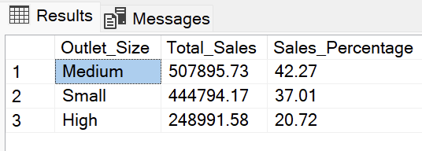

- SALES BY OUTLET LOCATION:
SELECT Outlet_Location_Type,
CAST(SUM(Total_Sales) AS DECIMAL(10, 2)) AS Total_Sales
FROM blinkit_sales
GROUP BY Outlet_Location_Type
ORDER BY Total_Sales DESC

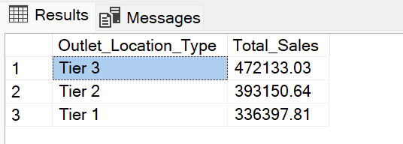

- ALL METRICS BY OUTLET TYPE:
SELECT Outlet_Type,
CAST(SUM(Total_Sales) AS DECIMAL(10,2)) AS Total_Sales,
CAST(AVG(Total_Sales) AS DECIMAL(10, 0)) AS Avg_Sales,
COUNT(*) AS No_Of_Items,
CAST(AVG(Rating) AS DECIMAL(10,2)) AS Avg_Rating,
CAST(AVG(Item_Visibility) AS DECIMAL(10, 2)) AS Item_Visibility
FROM blinkit_sales
GROUP BY Outlet_Type
ORDER BY Total_Sales DESC

